Task 1: Signal creation

Parameters
- Number of harmonic components: 4

- Frequencies:
  - f1 = 41 Hz, with amplitude 1.5
  - f2 = 82 Hz, with amplitude 3
  - f3 = 123 Hz, with amplitude 4.5
  - f4 = 164 Hz, with amplitude 6

- Sampling frequency: fs = 5000 Hz

- Total samples: 4096 (N=1024, M=4 sections)

- Noise: Gaussian white noise, σ = 2, variance (σ² = 4)

Below are plots of the Signal, the Noisy Signal, as well as the Noise. As instructed, the signal was additionally divided into 4 different sections.

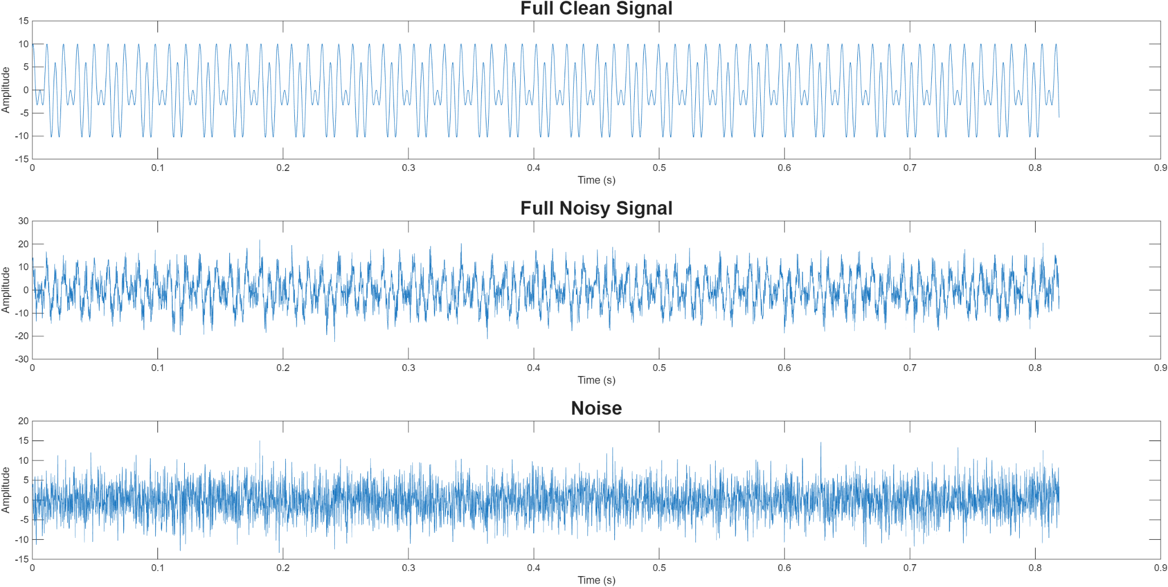
Figure 1: Full plots of Clean, Noisy, and noise signals.

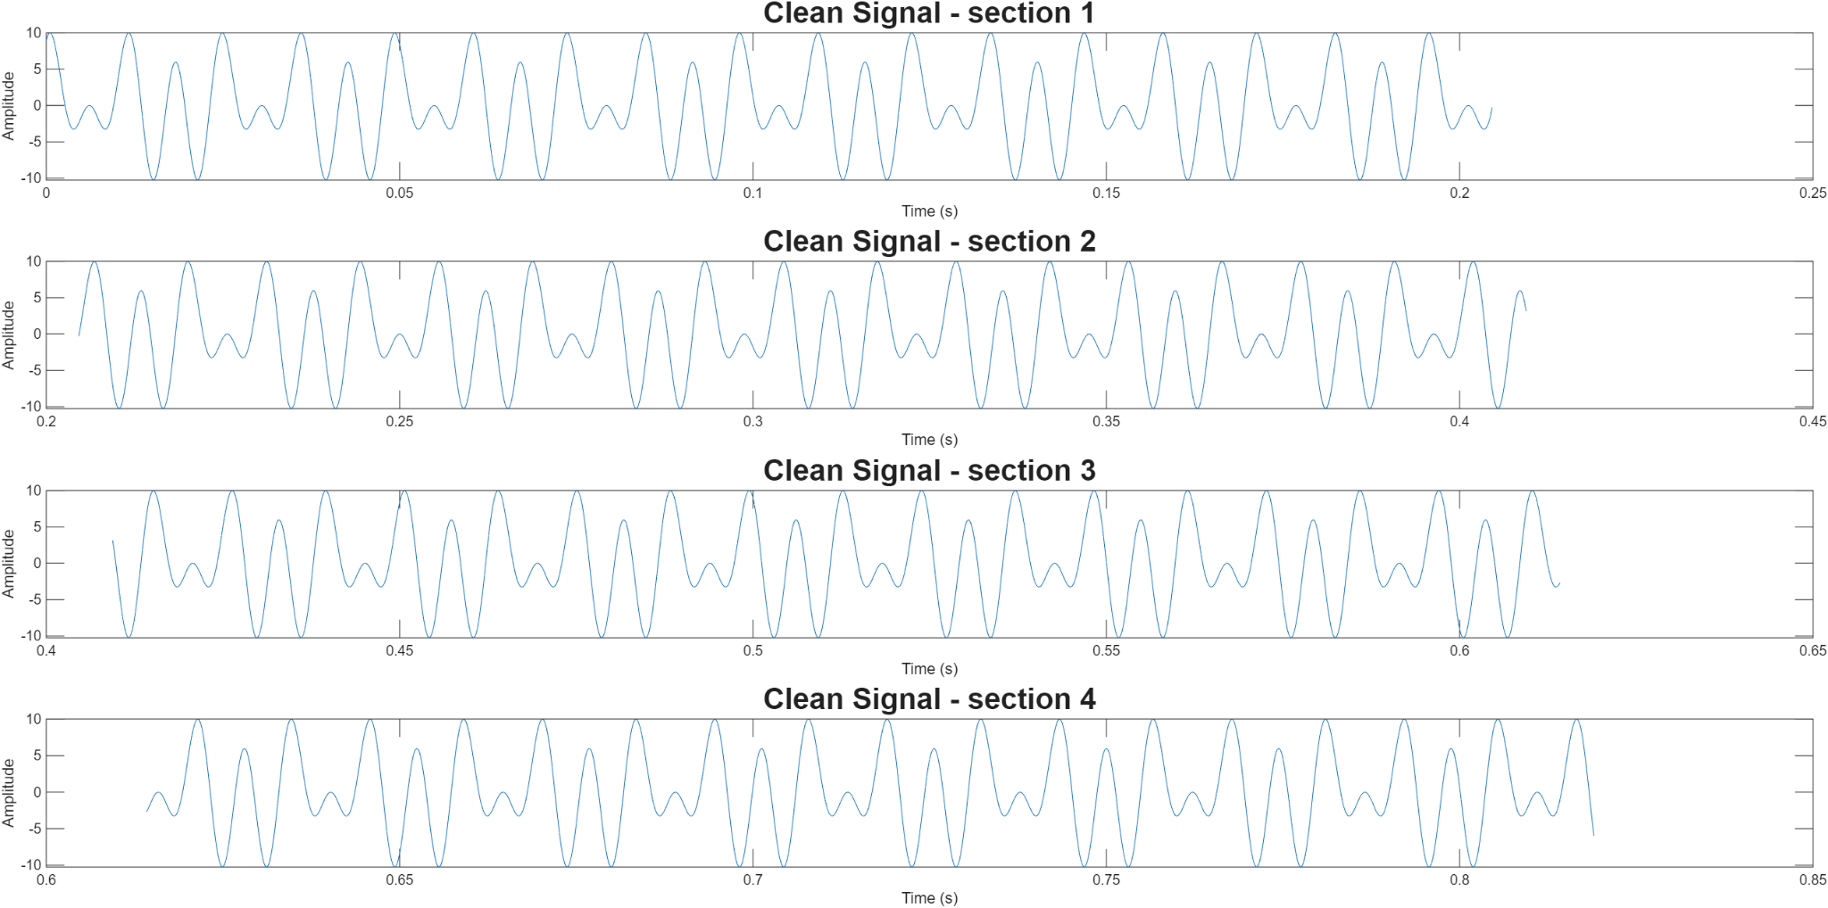
Figure 2: 4 Sections of Clean Signal.
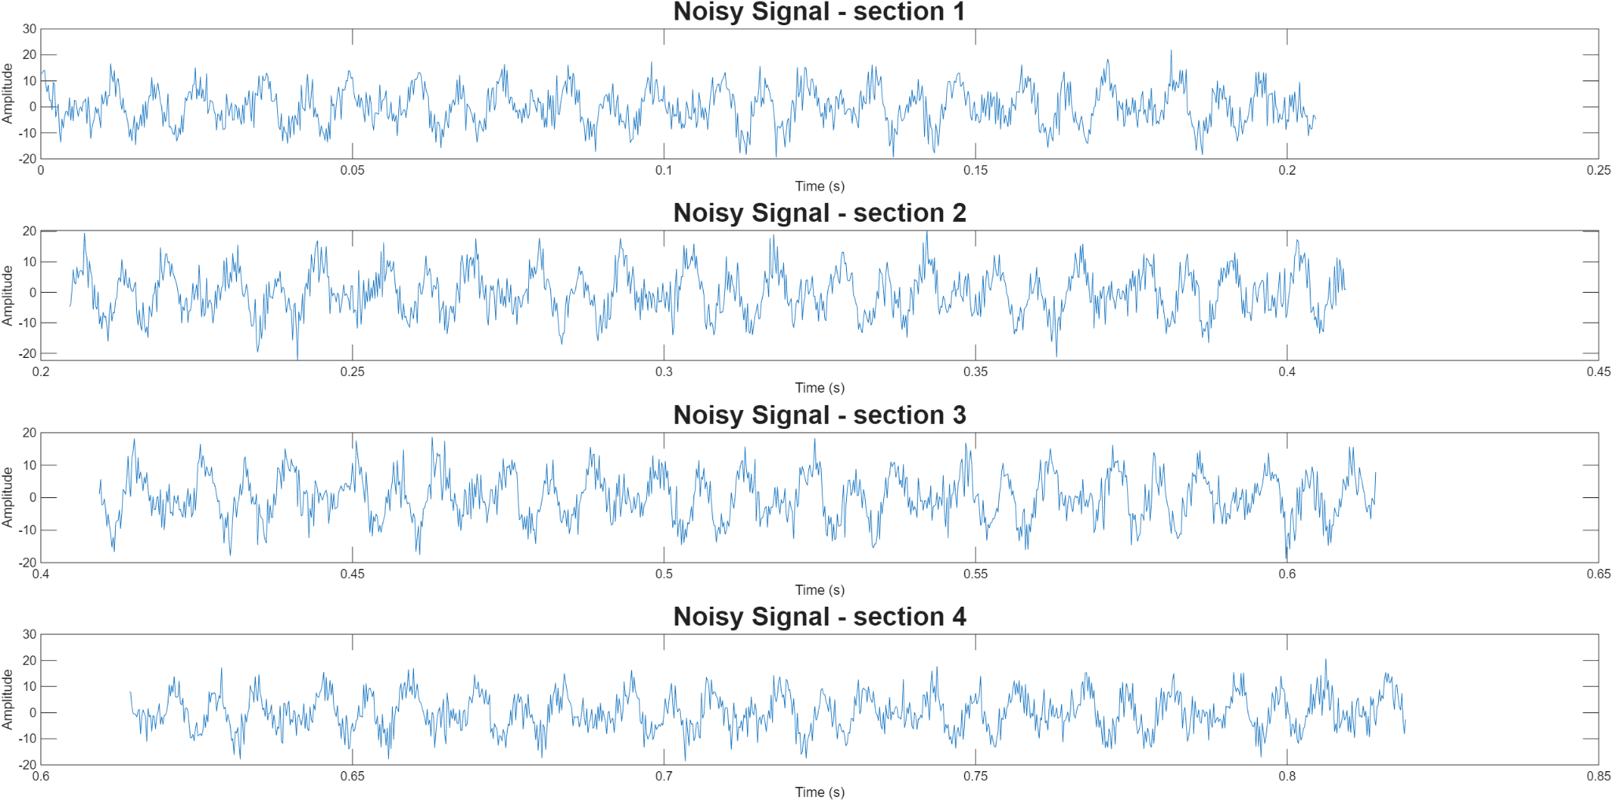
Figure 3: 4 Sections of Noisy Signal

Justification of Parameters
1. Choice of Harmonic Components
The signal is composed of four harmonic components corresponding to the fundamental and harmonics of the low E string of a bass guitar, the instrument I personally play. Using harmonics of the musical note allowed for clear distinct frequencies equally separate from each other.
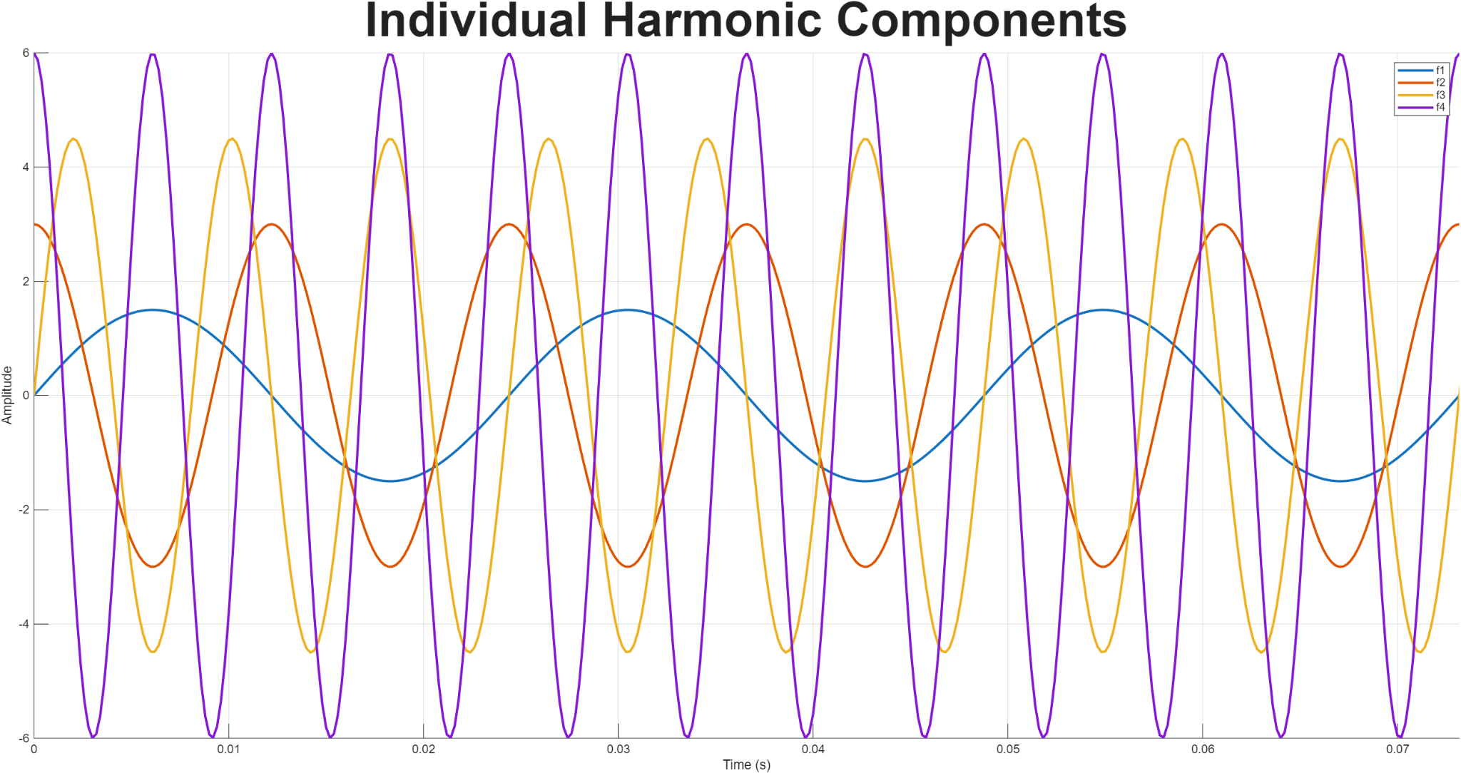
Figure 4: The Four Individual Harmonic Components
2. Choice of Amplitudes
The Amplitudes were chosen in such a way that each frequency is clearly distinguishable, yet they are not too far off from each other. When experimenting with other amplitudes, given the ratio was the same, amplitude level made little difference.
Additionally, the amplitudes were done in a descending order, so that the frequency which is chosen to be isolated (f1) produces clear results if filtered properly
3. Sampling Frequency and Samples
Sampling frequency of 5000 Hz provided the best results in terms of smoothness of the plotting and outcome of the graphs. As a result of a relatively high frequency, an N value of 1024 provided suitable results; lower values resulted in unclear Frequency spectrum plots where the spectral peaks appeared gradual and spread out rather than sharp.
4. Gaussian noise
The noise standard deviation being allocated a value of 4 allowed the filter to still be tested as the signal was still degraded by noise. However, with higher values, performance quickly started to drop, as the spectral peaks of the filtered signal were less distinct, having numerous peaks rather than a single peak.

Task 2: Filter Creation
A Low pass filter, which isolates frequencies below 60 Hz was chosen, so as to be able to isolate the f1 harmonic component of the signal, which has 41Hz.

Parameters
Filter Type: FIR Low-Pass

- Sampling Frequency (Fs): 5000 Hz

- Filter Order (N): 200

- Cutoff Frequency (Fc): 60 Hz

- Window Type: Kaiser Window

- Window Parameter (β): 2

Justification of Parameters
1. Sampling Frequency
Sampling frequency was chosen as 5000 Hz so to match the sampling rate of the signal generation.
2. Filter order
A relatively high order (200) allowed the creation of a steep transition band around the cutoff frequency; this was implemented because the harmonic components have relatively close frequencies. Lower orders ended up with leakage of other harmonics through the passband
3. Cutoff Frequency
60 Hz was the middle-ground between the first and second harmonic components (41 Hz and 82 Hz); it allowed to start attenuation of the signal well before the second harmonic, thus completely containing the full first harmonic component after filtering.
4. Window Type
I used a window-based FIR filter because it is the easiest and most straightforward method MATLAB offers for designing a clean, stable low-pass filter, and many sources online pointed to using the Kaiser Window. This is because it gives a good balance between smooth filtering and strong noise/harmonic reduction, and its adjustable parameter (β) lets you control how strong the filtering is. A β of 2 was chosen which provided a smooth transition band and a moderate stop band attenuation; enough to provide decent results.

Plotting

Magnitude and Phase Response

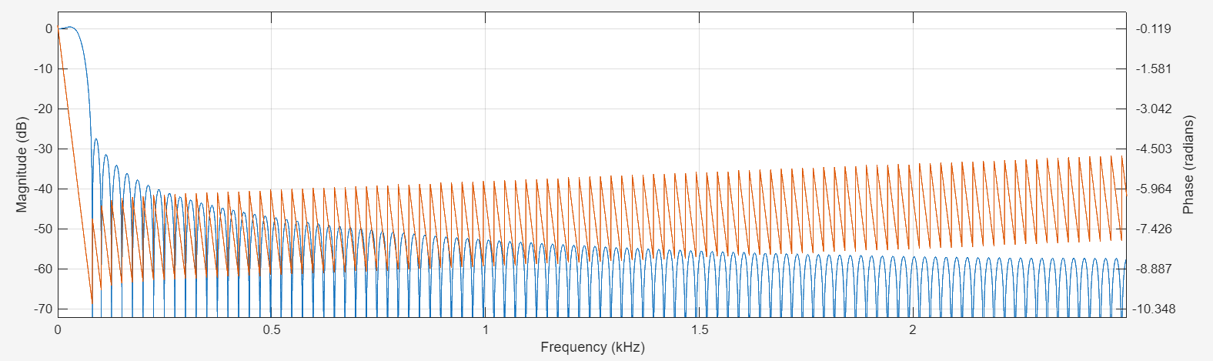
Figure 5: Magnitude and Phase Response of the Filter.
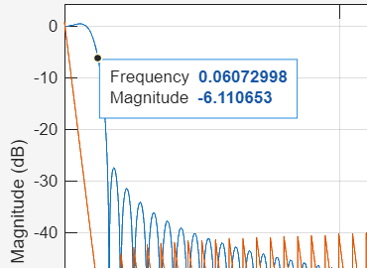
Figure 6: Zoom in on Magnitude, highlighting the main point of the sharp decrease.
The magnitude of the filter starts to sharply cut off after around 60 Hz, as shown by Figure 6 where the frequency of 60 Hz is highlighted (The graph shows 0.06 because it is in KHz). This is expected, due to the cutoff being 60Hz. The phase, after also drastically decreasing, increases linearly with frequency because the FIR filter applies a constant time delay to all frequencies, and higher frequencies accumulate more phase shifts over the same delay.

Impulse Response
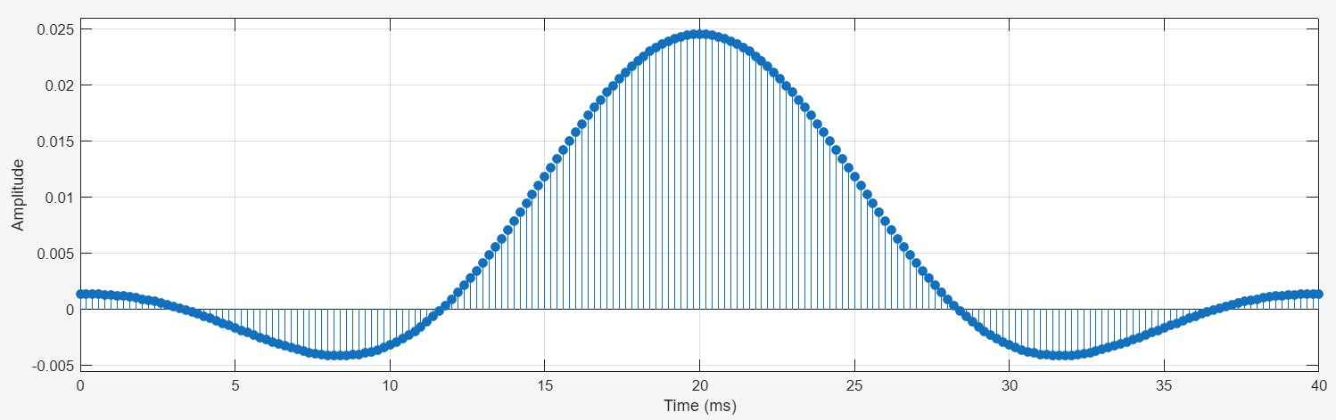
Figure 7: Impulse Response of the Filter.

The peak coefficient of 0.25 means that the central input sample contributes 25% to the output at that moment; the other samples contribute less, and together they preserve the low-frequency signal. The impulse response is stretched because the low cutoff frequency spreads the filter’s coefficients over many samples, giving it a wide bell shape.

Distribution of zero points and poles on the unit circle
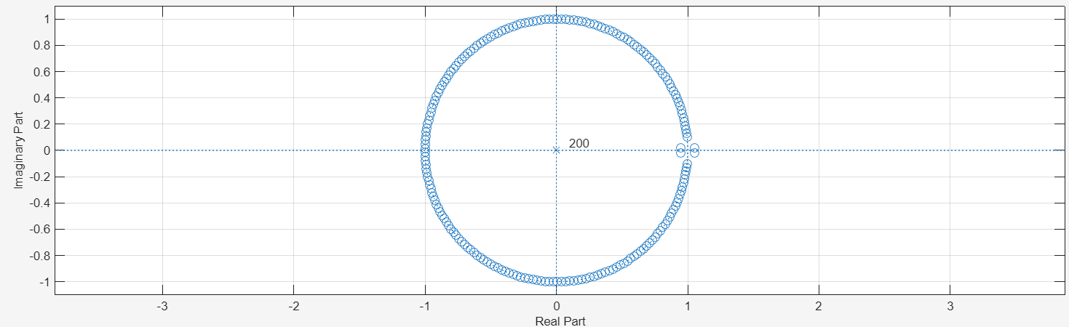
Figure 8: Distribution of Zero points and poles.

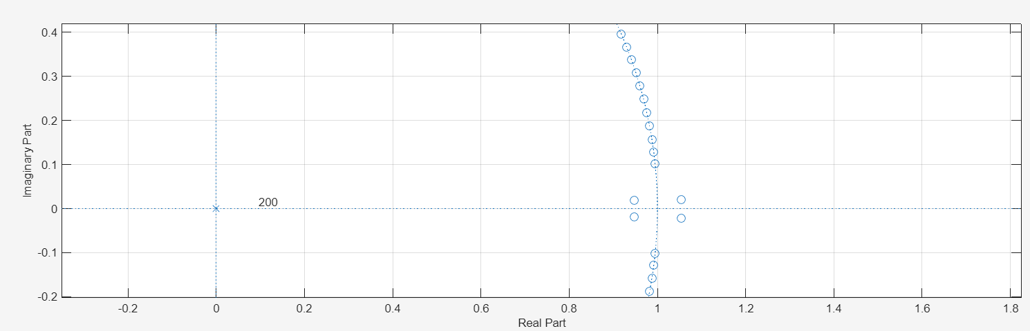
Figure 9: Zoom in of Gap of evenly distributed zeros along the unit circle.
The filter is FIR, so all poles are at the origin, as confirmed by the diagram. The zeros are mostly evenly distributed around the unit circle to block high-frequency components, but there is a gap near the 0 radian point (low-frequency region) as shown in Figure 9. This confirms correct implementation of the filter as since there are no zeros in that region to attenuate, the low frequencies of the signal can pass through.

Filtered Signal
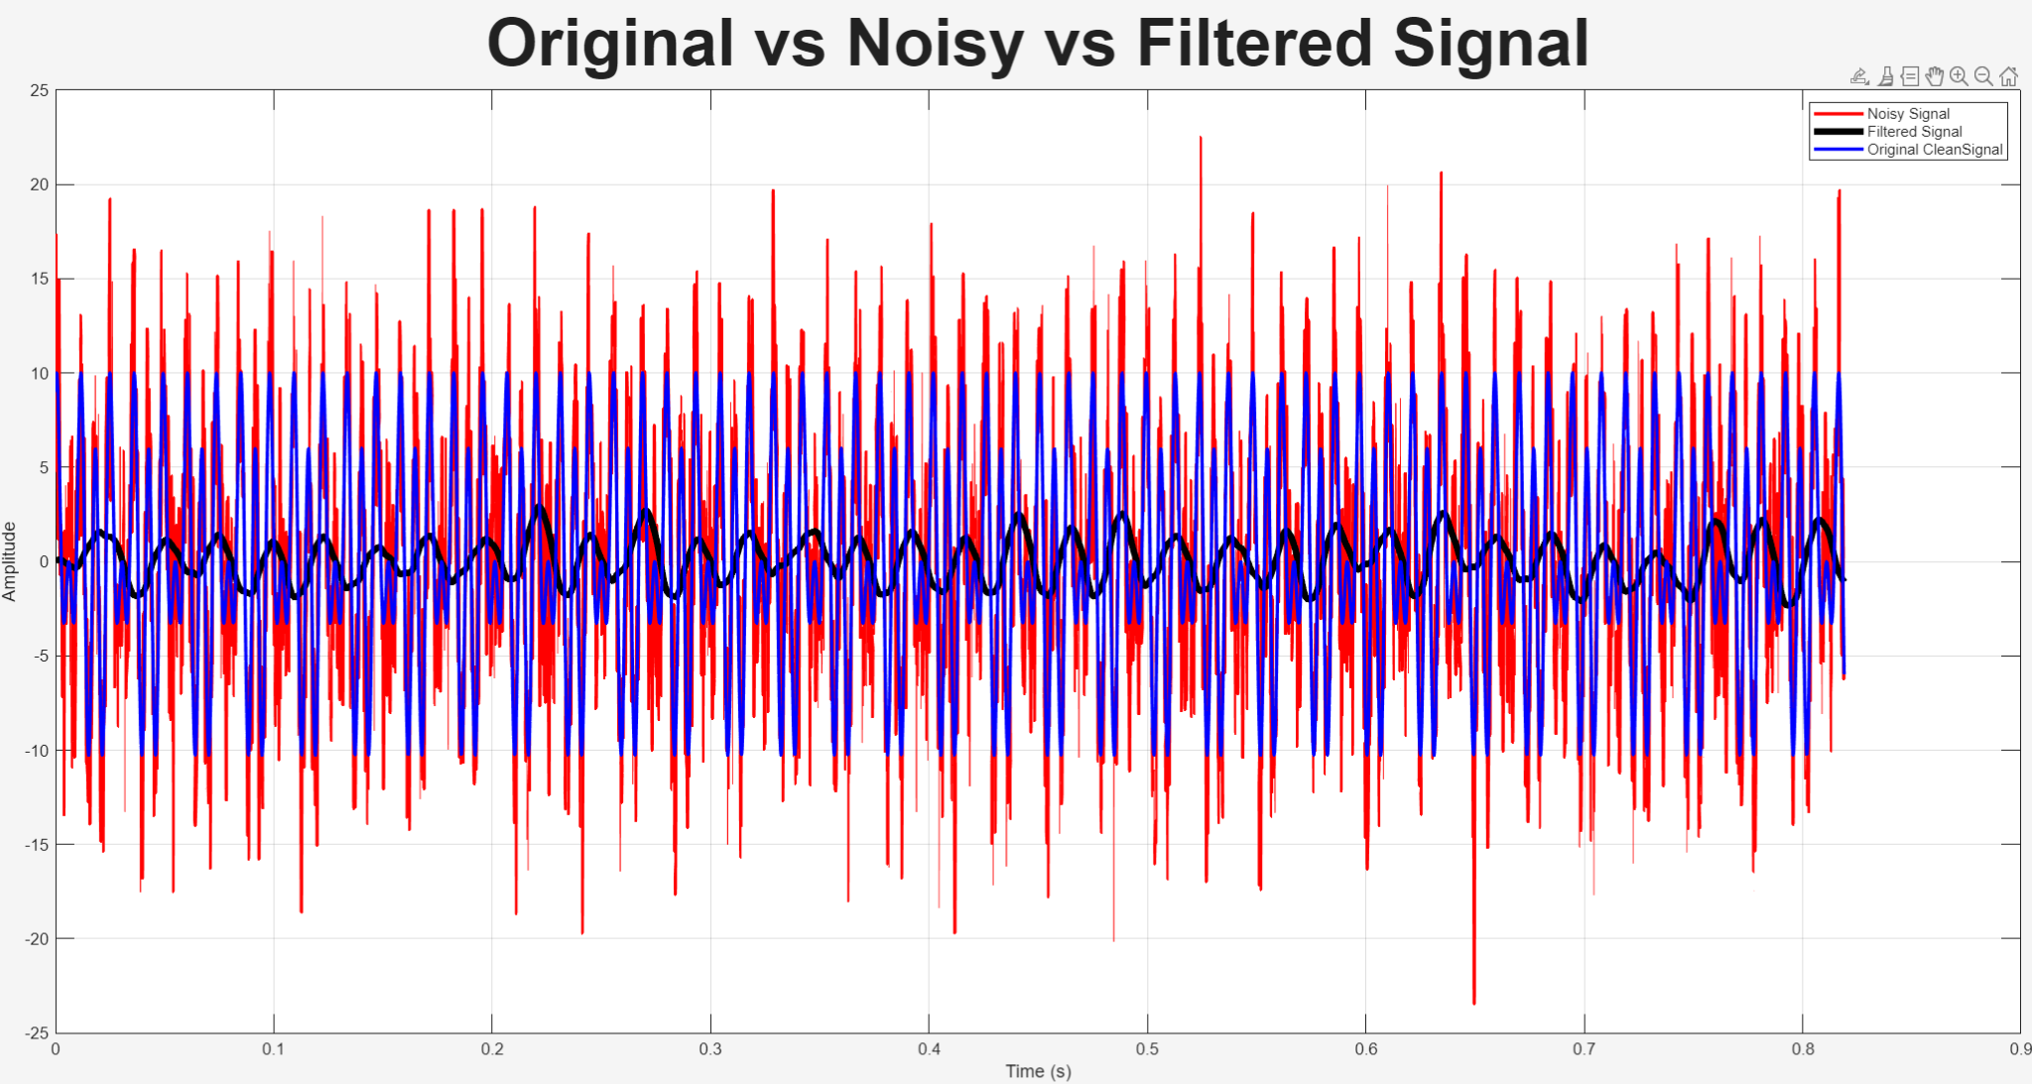
Figure 10: Original (blue), Noisy (red), and Filtered (black) Signals

This Plot effectively shows that the filter worked relatively well. From the noisy signal, it managed to isolate all frequencies under 60Hz, leaving in the signal only the F1 frequency of 41Hz, which had an amplitude of 1.5. This is effectively shown since the filtered signal rarely surpasses 1.5 in amplitude, as shown in the figure below.
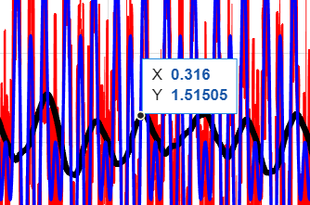
Figure 11: Emphasis on filter managing to isolate F1 frequency

Spectra
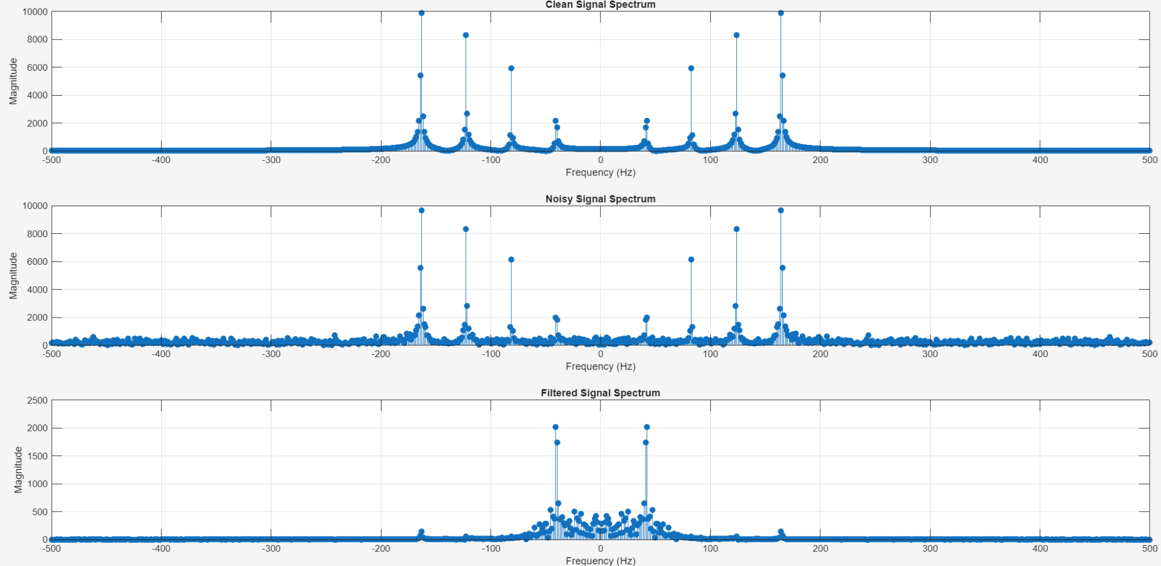
Figure 12: Spectra of Signals (from top to bottom: Clean, noisy, filtered)

In the Clean and noisy signal spectra, the peaks clearly indicate the four harmonic components and their respective magnitudes. The filtered signal spectrum only shows peaks within the +- 60 Hz range, meaning that the cutoff of 60 Hz worked effectively, and the filter only allowed the first harmonic component of 41 Hz and below through.

